Document Name |  | Confidentiality Level
DBMS Project |  | Only for Recipients Reference
Template Code | Version | Document Code
 | 3.0

DBMS Project Closure Summary Report

DBMS 12

Copyright © DBMS12 Co., Ltd.
All Rights Reserved
Revision Record
Date | Revision Version | CR ID /Defect ID | Sec No. | Change Description | Author

Content
1. Project Basic Situation 3
2. Project Acceptance Coverage 3
2.1 Project progress 3
2.2 Development environment 4
2.3 Project Structure 4
2.4 Application 4
2.5 Deliverables 5
3. Project Work Summary 5
3.1 Code statistics 5
3.2 Document work summary 5
4. Lessons learned and Suggestions for Improvement 6

1. Project Basic Situation
Project Name: | DBMS | Project Category: | MFC
Project ID: |  | Technology Used: | MFC SDI
Development Environment: | Vs2013 | Running Platform: | Framework
Project Start & Finish Time: | Start 5.03.2017  Finish 6.20.2017 | Project Working Place:
  Windows
Project Manager: | 张瑜
Project Developer: | 杜月锌
Project Description | Database Management System is large-scale software which can manipulate and manage the database. It is used to establish, use and maintain the database, and called DBMS for short. It manages and controls the database in a unified manner to ensure the security and integrity of the database. The user accesses the data in the database through DBMS. The database administrator also maintains the database through DBMS. It can make many applications and users establish, modify and query the database through different methods at the same time or different moments. Most DBMS provide DDL (Data Definition Language) and DML (Data Manipulation Language) for users to define the schema structure and permission constraint of the database, and implement the data operations: add, delete, etc.

2. Project Acceptance Coverage

2.1 Project progress
(S.N.) | Stages | Scheduled start/end time | Actual start/end time | List of deliverables | Remarks
1 | Project start | 5.01-5.02 | 5.01-5.02 | Project Initiation Report | write
2 | Project planning | 5.01-5.03 | 5.01-5.03 | Project Planning | Read and fill
3 | Requirement analysis | 5.02-5.04 | 5.02-5.04 | Software Requirement Specification | Read and fill
4 | System design | 5.02-5.06 | 5.02-5.06 | Each iterative source code | Read and fill
5 | Coding and test | 5.06-5.24 | 5.06-6.19 | Finalized project codes | develop
6 | Acceptance | 6.19-6.20 | 6.19-6.20 | Useer Manual /  Project Closure Report | write

2.2 Development environment
System/Tool/Component | In English (version number) | Remarks
Operating system | Windows8.1
Development tool | VS2013

2.3 Project Structure
1. Project structure design idea
Prompt: describing how to fulfill design of project framework, as well as technology employment (or technological prototyping).
Program structure design
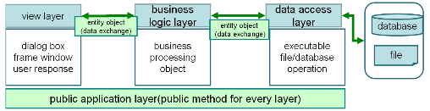
Based on the logic responsibility, the program software structure can be divided into 3 layers: presentation layer, business logic layer and data access layer. Data in each layer is transferred by “entity class0 (data object). Besides, public class that irrelative with business may be used in layers in the program as the "Tool class."

2. Project directory structure
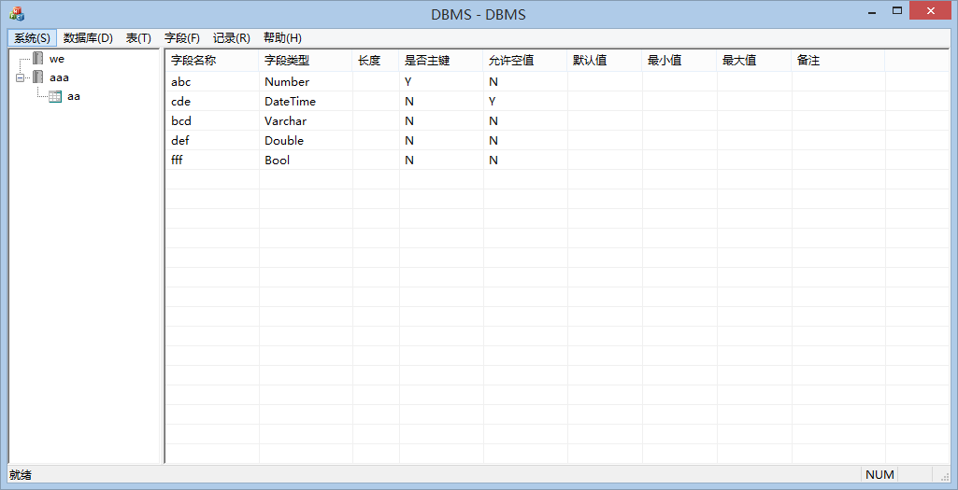

2.4 Application
1. Requirement Function: Create Database
(1) Functional description
By default, the system creates a database named “aaa”. The basic information of the database is saved in CDBEntity. Display the created database name with tree view CDBView: Through document class CRKDBMSDoc, pass the database information to the view class. Pass the database information to CDBLogic class with CRKDBMSDoc class. CDBLogic class passes the database information to CDBDao class. CDBDao class saves the database information in "Ruanko.db" file.
(2) Running screenshot
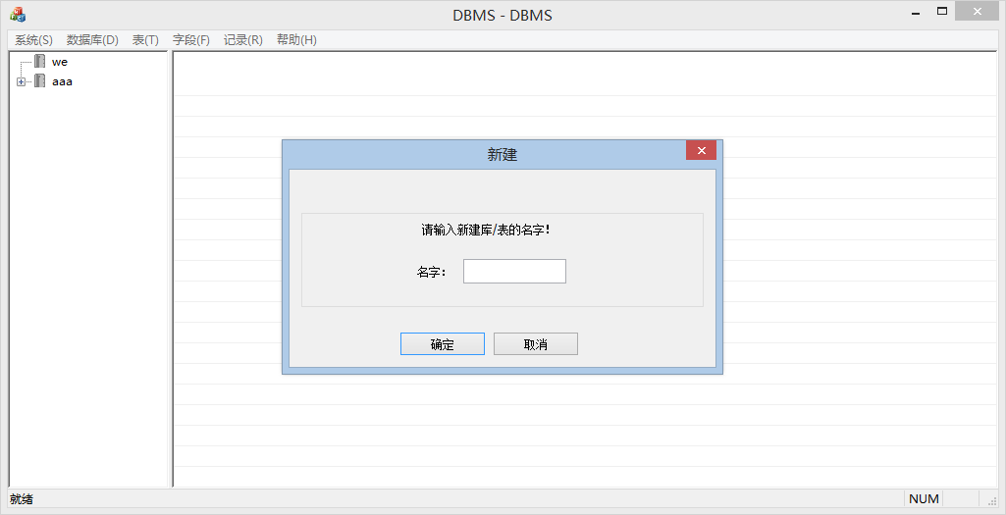

(3) Development idea and core code
bool CreateDB()
{
CStdioFile file;

if (file.Open(_T("file.txt"), CFile::modeReadWrite) == 0)
{
file.Open(_T("file.txt"), CFile::modeCreate | CFile::modeReadWrite);
file.Write("1", sizeof(int));
file.Write("\n", strlen("\n"));
}
else
{
CString str;
file.ReadString(str);
file.ReadString(str);
while (str != "")
{
if (str.Compare(name) == 0)
{
return false;
}
file.ReadString(str);
}
int n;
file.SeekToBegin();
file.Read(&n, sizeof(int));
n++;
file.SeekToBegin();
file.Write(&n, sizeof(int));
}
file.SeekToEnd();
USES_CONVERSION;
char* z = T2A(name);
file.Write(z, name.GetLength());
file.Write("\n", strlen("\n"));
file.Close();

_mkdir(z);

CString path = name + _T("\\") + _T("file.txt");

if(file.Open(path , CFile::modeReadWrite) == 0)
{
file.Open(path, CFile::modeCreate | CFile::modeReadWrite);
file.WriteString(_T("0\n"));
}

return true;
}
2. Requirement Function: Create Table
(1) Functional description
According to database name aaa, create a database table description file aaa.tb to save the table information in the database. By reading table description file (aaa.db), we can find the table structure definition file (*.tdf) and the data record file (*.trd).
(2) Running screenshot

(3) Development idea and core code
bool CreateTable()
{
CStdioFile file;
CString path = belongDB + _T("\\") + tableName + _T(".tbs");

if(file.Open(path , CFile::modeReadWrite) == 0)
{
file.Open(path, CFile::modeCreate | CFile::modeReadWrite);
file.WriteString(_T("0\n"));
}
file.Close();

path = belongDB + _T("\\") + tableName + _T(".tbd");

if(file.Open(path , CFile::modeReadWrite) == 0)
{
file.Open(path, CFile::modeCreate | CFile::modeReadWrite);
file.WriteString(_T("0\n"));
}
file.Close();

path = belongDB + _T("\\") + _T("file.txt");
if(file.Open(path , CFile::modeReadWrite))
{
char num[4];
file.SeekToBegin();
file.Read(&num, sizeof(int));
int n = atoi(num);
char a[4];
n++;
_itoa_s(n, a, 4, 10);
file.SeekToBegin();
file.Write(a, sizeof(int));
file.Write("\n", strlen("\n"));
file.SeekToEnd();
file.WriteString(tableName+_T("\n"));
}
file.Close();
return true;
}

3. Requirement Function: Insert、delete、modify、select of data record.
(1) Functional description
Insert、delete、modify、select of data record.
(2) Running screenshot
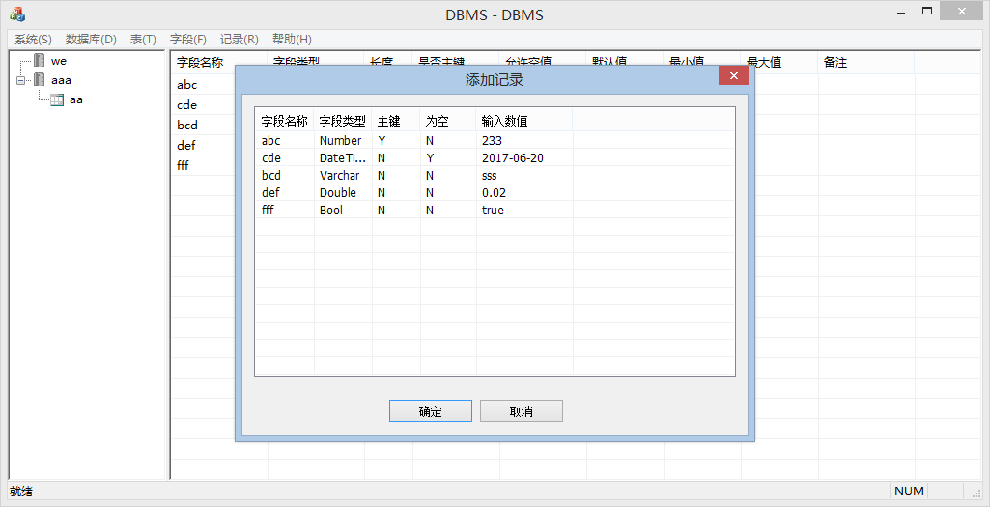

(3) Development idea and core code
bool writeRecord(CString DBname,CString TBname,std::map<CString, CString> &mp)
{
std::vector<Field> v;
TableEntity te;
te.getAttributes(DBname,TBname,v);

// ================================================================
// 建索引文件
std::vector<std::map<CString, CString>> allrcrds;
int count;
readRecord(DBname, TBname, allrcrds, count);

for (int i = 0; i < v.size(); i++)
{
if (v[i].m_Primary == "Y")
{
P = v[i].m_FieldName;
break;
}
}
allrcrds.push_back(mp);
sort(allrcrds.begin(), allrcrds.end(), &RecordEntity::comparer);
CStdioFile index;
CString indexpath = DBname + _T("\\") + TBname + _T(".ndx");
if (index.Open(indexpath, CFile::modeCreate | CFile::modeReadWrite) == 0)
{
return false;
}
else
{
index.SeekToBegin();
int fl = 0;
for (int i = 0; i < allrcrds.size(); i++)
{
USES_CONVERSION;
CString value = allrcrds[i][P];
char* z = T2A(value);
index.Write(z, allrcrds[i][P].GetLength());
index.Write("\n", strlen("\n"));
for (int j = 0; j < i; j++)
{
for (int k = 0; k < v.size(); k++)
{
fl += allrcrds[j][v[k].m_FieldName].GetLength();
}
}
char a[4];
_itoa_s(fl, a, 4, 10);
index.Write(a, sizeof(int));
index.Write("\n", strlen("\n"));
}
}
index.Close();
// ==========================================================索引文件创建完成/

CStdioFile file;
CString path = DBname + _T("\\") + TBname + _T(".tbd");

if (file.Open(path, CFile::modeReadWrite) == 0)
{
return false;
}
else
{
CString str;
CString* s;
int n;
char num[4];
file.SeekToBegin();
file.Read(&num, sizeof(int));
n = atoi(num);
s = new CString[n];
n++;
file.SeekToBegin();
char a[4];
_itoa_s(n, a, 4, 10);
file.Write(a, sizeof(int));
file.Write("\n", strlen("\n"));
file.SeekToEnd();

for(int i=0;i<v.size();i++)
{
USES_CONVERSION;
CString value = mp[v[i].m_FieldName];
char* z = T2A(value);
file.Write(z, value.GetLength());
file.Write("\n", strlen("\n"));
}
}
file.Close();
return true;
}

bool readRecord(CString DBname,CString TBname,std::vector<std::map<CString, CString>> &vct,int &n)
{
std::vector<Field> v;
TableEntity te;
te.getAttributes(DBname,TBname,v);

CStdioFile file;
vct.clear();
CString path = DBname + _T("\\") + TBname + _T(".tbd");

if (file.Open(path, CFile::modeReadWrite) == 0)
{
return false;
}
else
{
CString str;
CString* s;
char num[4];
file.SeekToBegin();
file.Read(&num, sizeof(int));
n = atoi(num);
file.ReadString(str);
for (int i = 0; i < n; i++)
{
std::map<CString, CString> mp;
mp.clear();
for(int j=0;j<v.size();j++)
{
file.ReadString(str);
CString key = v[j].m_FieldName;
mp.insert(std::make_pair(key,str));
}
vct.push_back(mp);
}
file.Close();
}
return true;
}

bool deleteRecord(CString DBname,CString TBname,std::map<CString,CString> &Map)
{
std::vector<Field> v;
TableEntity te;
te.getAttributes(DBname,TBname,v);

CStdioFile file;

std::vector<std::map<CString, CString>> vct;
vct.clear();

CString path = DBname + _T("\\") + TBname + _T(".tbd");

if (file.Open(path, CFile::modeReadWrite) == 0)
{
return false;
}
else
{
CString str;
CString* s;
char num[4];
file.SeekToBegin();
file.Read(&num, sizeof(int));
int n = atoi(num);
file.ReadString(str);
for (int i = 0; i < n; i++)
{
std::map<CString, CString> mp;
mp.clear();
for(int j=0;j<v.size();j++)
{
file.ReadString(str);
CString key = v[j].m_FieldName;
mp.insert(std::make_pair(key,str));
}
vct.push_back(mp);
}
file.Close();
file.Open(path, CFile::modeCreate|CFile::modeReadWrite);
file.SeekToBegin();
char a[4];
_itoa_s(n-1, a, 4, 10);
file.Write(a, sizeof(int));
file.Write("\n", strlen("\n"));

for(int i=0;i<n;i++)
{
std::map<CString,CString> mp;
mp = vct[i];
bool flag = false;

for(int j=0;j<v.size();j++)
{
CString p = mp[v[j].m_FieldName];
CString primary = Map[v[j].m_FieldName];
if(p==primary)
{
flag = false;
}
else
{
flag = true;
break;
}
}

if(flag)
{
for(int j=0;j<v.size();j++)
{
USES_CONVERSION;
CString value = mp[v[j].m_FieldName];
char* z = T2A(value);
file.Write(z, value.GetLength());
file.Write("\n", strlen("\n"));
}
}
}

file.Close();
}
}

bool updateRecord(CString DBname,CString TBname,std::map<CString,CString> &newMap,std::map<CString,CString> &oldMap)
{
std::vector<Field> v;
TableEntity te;
te.getAttributes(DBname,TBname,v);

CStdioFile file;

std::vector<std::map<CString, CString>> vct;
vct.clear();

CString path = DBname + _T("\\") + TBname + _T(".tbd");

if (file.Open(path, CFile::modeReadWrite) == 0)
{
return false;
}
else
{
CString str;
CString* s;
char num[4];
file.SeekToBegin();
file.Read(&num, sizeof(int));
int n = atoi(num);
file.ReadString(str);
for (int i = 0; i < n ; i++)
{
std::map<CString, CString> mp;
mp.clear();
for(int j=0;j<v.size();j++)
{
file.ReadString(str);
CString key = v[j].m_FieldName;
mp.insert(std::make_pair(key,str));
}
vct.push_back(mp);
}
file.Close();
file.Open(path, CFile::modeCreate|CFile::modeReadWrite);
file.SeekToBegin();
char a[4];
_itoa_s(n, a, 4, 10);
file.Write(a, sizeof(int));
file.Write("\n", strlen("\n"));

for(int i=0;i<n ;i++)
{
std::map<CString,CString> mp;
mp = vct[i];
bool flag = false;

for(int j=0;j<v.size();j++)
{
CString p = mp[v[j].m_FieldName];
CString primary = oldMap[v[j].m_FieldName];
if(p==primary)
{
flag = false;
}
else
{
flag = true;
break;
}
}

if(flag)
{
for(int j=0;j<v.size();j++)
{
USES_CONVERSION;
CString value = mp[v[j].m_FieldName];
char* z = T2A(value);
file.Write(z, value.GetLength());
file.Write("\n", strlen("\n"));
}
}
else
{
for(int j=0;j<v.size();j++)
{
USES_CONVERSION;
CString value = newMap[v[j].m_FieldName];
char* z = T2A(value);
file.Write(z, value.GetLength());
file.Write("\n", strlen("\n"));
}
}
}

file.Close();
}
}

4. Requirement Function: SQL analysis.
(1) Functional description
SQL analysis.
(2) Running screenshot
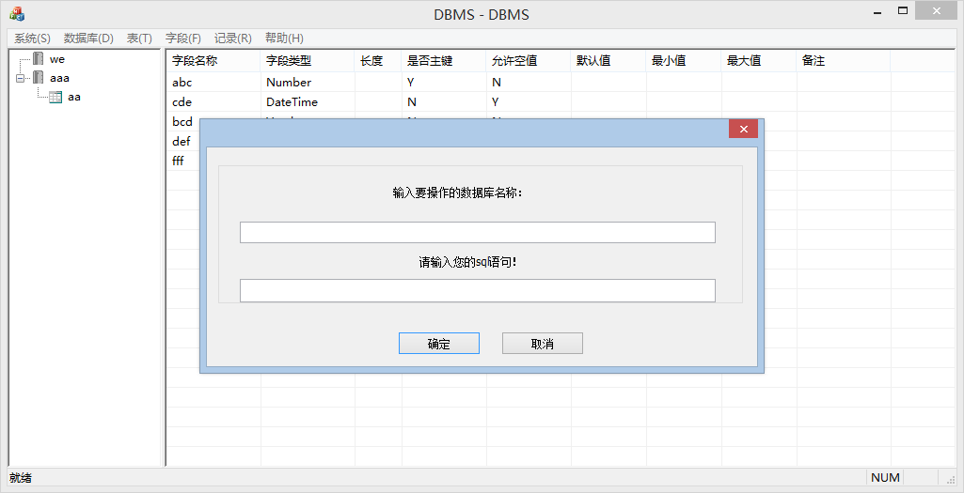

(3) Development idea and core code
void SQLDlg::OnBnClickedOk()
{
// TODO: 在此添加控件通知处理程序代码
m_dbname.GetWindowTextW(m_db);
m_eSql.GetWindowTextW(m_sql);
Analysis(m_db,m_sql);
// 获取m_pTableView对象，后面加pMainWnd->m_pTableView->
// 获取m_pDBView对象，后面加pMainWnd->m_pDBView->

CDialog::OnOK();
}
void SQLDlg::Analysis(CString db,CString sql){
CString output;
CMainFrame *pMainWnd = (CMainFrame *)AfxGetMainWnd();
CTreeCtrl *tree=&pMainWnd->m_pDBView->GetTreeCtrl();

AfxExtractSubString(output,sql,0,' ');

if(output=="create"){//建表或者建库
AfxExtractSubString(output,sql,1,' ');

if(output=="database"){

AfxExtractSubString(output,sql,2,' ');
if (!output.IsEmpty())
{
HTREEITEM hRoot = tree->InsertItem(output, 0, 0, TVI_ROOT, TVI_LAST);
tree->Expand(hRoot, TVE_EXPAND);
}

DBEntity entity(output);
entity.CreateDB();
}else if(output=="table"){
HTREEITEM hItem1;
HTREEITEM hNode;
HTREEITEM hItem;

AfxExtractSubString(output,sql,2,' ');

if (!output.IsEmpty()){
hItem = tree->GetSelectedItem();
if (tree->GetParentItem(hItem) != 0)
{

hItem1 = tree->GetParentItem(hItem);
hNode = tree->InsertItem(output, 1, 1, hItem1);
tree->Expand(hItem1, TVE_EXPAND);
}
else
{
hNode = tree->InsertItem(output, 1, 1, hItem);
tree->Expand(hItem, TVE_EXPAND);
}
}

TableEntity TBentity(output,db);
TBentity .CreateTable();
}

}else if(output=="drop"){ //删除
AfxExtractSubString(output,sql,1,' ');

if(output=="database"){

AfxExtractSubString(output,sql,2,' ');
HTREEITEM hItem1;
HTREEITEM hItem = tree->GetSelectedItem();

if (tree->GetParentItem(hItem) != 0)
{
hItem1 = tree->GetParentItem(hItem);
tree->DeleteItem(hItem1);
}
else
tree->DeleteItem(hItem);

DBEntity entity(output);
entity.DropDB(output);
}else if(output=="table"){
AfxExtractSubString(output,sql,2,' ');

HTREEITEM hItem = tree->GetSelectedItem();

CString tableName = tree->GetItemText(hItem);
HTREEITEM hParent = tree->GetParentItem(hItem);
CString DBname = tree->GetItemText(hParent);
if (tree->GetParentItem(hItem) != 0)
tree->DeleteItem(hItem);

TableEntity entity;
entity.DropTable(DBname,tableName);

}
}

else if (output=="select"){
AfxExtractSubString(output,sql,1,' ');
if(output=="*"){
CString m_SelectDBName,m_SelectTBName;
HTREEITEM hItem,hItem1;

// 获得当前选中的表的名字
hItem = tree->GetSelectedItem();
m_SelectTBName = tree->GetItemText(hItem);
// 获得当前选中的库的名字
hItem1 = tree->GetParentItem(hItem);
m_SelectDBName = tree->GetItemText(hItem1);

/************从文件中取数据**********/
CString tbName = STBName,dbName = SDBName;
TableEntity entity;
std::vector<Field> v;
entity.getAttributes(dbName,tbName,v);
int n = v.size();
/***********************************/
// 清空表
CMainFrame *pMainWnd = (CMainFrame *)AfxGetMainWnd();
pMainWnd->m_pTableView->ClearTable();

pMainWnd->m_pTableView->DisplayRecords(1); // DisplayRecords方法参数不全

}else{
CString m_SelectDBName,m_SelectTBName;
HTREEITEM hItem,hItem1;

// 获得当前选中的表的名字
hItem = tree->GetSelectedItem();
m_SelectTBName = tree->GetItemText(hItem);
// 获得当前选中的库的名字
hItem1 = tree->GetParentItem(hItem);
m_SelectDBName = tree->GetItemText(hItem1);

/************从文件中取数据**********/
CString tbName = STBName,dbName = SDBName;
TableEntity entity;
std::vector<Field> v;
entity.getAttributes(dbName,tbName,v);
int n = v.size();
/***********************************/
// 清空表
CMainFrame *pMainWnd = (CMainFrame *)AfxGetMainWnd();
pMainWnd->m_pTableView->ClearTable();

pMainWnd->m_pTableView->DisplaySelectRecords(1); // DisplayRecords方法参数不全

}

}
}

5. Requirement Function: Insert、delete、modify of field.
(1) Functional description
According to the table name, create the table definition file (*.tdf) to save the table structure defined by users. Save the file path into the table description file. By reading the table description file, we can find the table definition file (*.tdf). Save the field information into die table definition file.
(2) Running screenshot
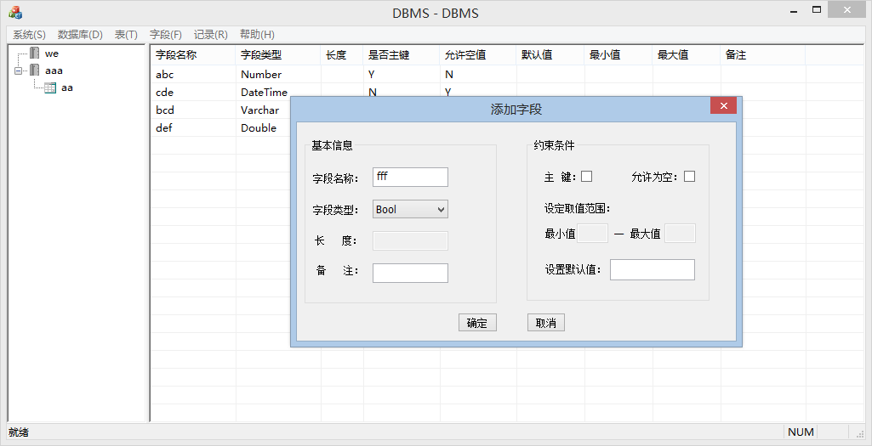

(3) Development idea and core code
bool addAttribute(Field &field, CString DBname,CString TBname)
{
CStdioFile file;
CString path = DBname + _T("\\") + TBname + _T(".tbs");
if (file.Open(path, CFile::modeReadWrite) == 0)
{
return false;
}
else
{
CString str;
CString* s;
int n;
char num[4];
file.SeekToBegin();
file.Read(&num, sizeof(int));
n = atoi(num);
s = new CString[n];
n++;
file.SeekToBegin();
char a[4];
_itoa_s(n, a, 4, 10);
file.Write(a, sizeof(int));
file.Write("\n", strlen("\n"));
file.SeekToEnd();
USES_CONVERSION;
char* z = T2A(field.m_FieldName);
file.Write(z, field.m_FieldName.GetLength());
file.Write("\n", strlen("\n"));

z = T2A(field.m_FieldType);
file.Write(z, field.m_FieldType.GetLength());
file.Write("\n", strlen("\n"));

z = T2A(field.m_Length);
file.Write(z, field.m_Length.GetLength());
file.Write("\n", strlen("\n"));

z = T2A(field.m_Hint);
file.Write(z, field.m_Hint.GetLength());
file.Write("\n", strlen("\n"));

z = T2A(field.m_Primary);
file.Write(z, field.m_Primary.GetLength());
file.Write("\n", strlen("\n"));

z = T2A(field.m_Null);
file.Write(z, field.m_Null.GetLength());
file.Write("\n", strlen("\n"));

z = T2A(field.m_Min);
file.Write(z, field.m_Min.GetLength());
file.Write("\n", strlen("\n"));

z = T2A(field.m_Max);
file.Write(z, field.m_Max.GetLength());
file.Write("\n", strlen("\n"));

z = T2A(field.m_Default);
file.Write(z, field.m_Default.GetLength());
file.Write("\n", strlen("\n"));
file.Close();
}
return true;
}

bool getAttributes(CString DBname,CString TBname,std::vector<Field> &v)
{
CStdioFile file;
v.clear();
CString path = DBname + _T("\\") + TBname + _T(".tbs");
if (file.Open(path, CFile::modeReadWrite) == 0)
{
return false;
}
else
{
CString str;
CString* s;
int n;
char num[4];
file.SeekToBegin();
file.Read(&num, sizeof(int));
n = atoi(num);
Field tmp;
file.ReadString(str);
for (int i = 0; i < n; i++)
{
file.ReadString(tmp.m_FieldName);
file.ReadString(tmp.m_FieldType);
file.ReadString(tmp.m_Length);
file.ReadString(tmp.m_Hint);
file.ReadString(tmp.m_Primary);
file.ReadString(tmp.m_Null);
file.ReadString(tmp.m_Min);
file.ReadString(tmp.m_Max);
file.ReadString(tmp.m_Default);
v.push_back(tmp);
}
file.Close();
}
return true;
}

bool updateTable(Field oldField,Field newField,CString DBname,CString TBname)
{
CStdioFile file;
std::vector<Field> v;
Field field;
v.clear();
CString path = DBname + _T("\\") + TBname + _T(".tbs");
if (file.Open(path, CFile::modeReadWrite) == 0)
{
return false;
}
else
{
CString str;
CString* s;
int n;
char num[4];
file.SeekToBegin();
file.Read(&num, sizeof(int));
n = atoi(num);
Field tmp;
file.ReadString(str);
for (int i = 0; i < n; i++)
{
file.ReadString(tmp.m_FieldName);
file.ReadString(tmp.m_FieldType);
file.ReadString(tmp.m_Length);
file.ReadString(tmp.m_Hint);
file.ReadString(tmp.m_Primary);
file.ReadString(tmp.m_Null);
file.ReadString(tmp.m_Min);
file.ReadString(tmp.m_Max);
file.ReadString(tmp.m_Default);
v.push_back(tmp);
}
file.Close();
file.Open(path, CFile::modeCreate|CFile::modeReadWrite);
file.SeekToBegin();
char a[4];
_itoa_s(n, a, 4, 10);
file.Write(a, sizeof(int));
file.Write("\n", strlen("\n"));
for (int i = 0; i < n; i++)
{
if (v[i].m_FieldName.Compare(oldField.m_FieldName) != 0)
{
field.m_FieldName = v[i].m_FieldName;
field.m_FieldType = v[i].m_FieldType;
field.m_Length = v[i].m_Length;
field.m_Hint = v[i].m_Hint;
field.m_Primary = v[i].m_Primary;
field.m_Null = v[i].m_Null;
field.m_Min = v[i].m_Min;
field.m_Max = v[i].m_Max;
field.m_Default = v[i].m_Default;
}
else
{
field.m_FieldName = newField.m_FieldName;
field.m_FieldType = newField.m_FieldType;
field.m_Length = newField.m_Length;
field.m_Hint = newField.m_Hint;
field.m_Primary = newField.m_Primary;
field.m_Null = newField.m_Null;
field.m_Min = newField.m_Min;
field.m_Max = newField.m_Max;
field.m_Default = newField.m_Default;
}
USES_CONVERSION;
char* z = T2A(field.m_FieldName);
file.Write(z, field.m_FieldName.GetLength());
file.Write("\n", strlen("\n"));

z = T2A(field.m_FieldType);
file.Write(z, field.m_FieldType.GetLength());
file.Write("\n", strlen("\n"));

z = T2A(field.m_Length);
file.Write(z, field.m_Length.GetLength());
file.Write("\n", strlen("\n"));

z = T2A(field.m_Hint);
file.Write(z, field.m_Hint.GetLength());
file.Write("\n", strlen("\n"));

z = T2A(field.m_Primary);
file.Write(z, field.m_Primary.GetLength());
file.Write("\n", strlen("\n"));

z = T2A(field.m_Null);
file.Write(z, field.m_Null.GetLength());
file.Write("\n", strlen("\n"));

z = T2A(field.m_Min);
file.Write(z, field.m_Min.GetLength());
file.Write("\n", strlen("\n"));

z = T2A(field.m_Max);
file.Write(z, field.m_Max.GetLength());
file.Write("\n", strlen("\n"));

z = T2A(field.m_Default);
file.Write(z, field.m_Default.GetLength());
file.Write("\n", strlen("\n"));
}
}
file.Close();
return true;
}

bool dropAttribute(CString DBname,CString TBname,CString fieldName)
{
CStdioFile file;
std::vector<Field> v;
Field field;
v.clear();
CString path = DBname + _T("\\") + TBname + _T(".tbs");
if (file.Open(path, CFile::modeReadWrite) == 0)
{
return false;
}
else
{
CString str;
CString* s;
int n;
char num[4];
file.SeekToBegin();
file.Read(&num, sizeof(int));
n = atoi(num);
Field tmp;
file.ReadString(str);
for (int i = 0; i < n; i++)
{
file.ReadString(tmp.m_FieldName);
file.ReadString(tmp.m_FieldType);
file.ReadString(tmp.m_Length);
file.ReadString(tmp.m_Hint);
file.ReadString(tmp.m_Primary);
file.ReadString(tmp.m_Null);
file.ReadString(tmp.m_Min);
file.ReadString(tmp.m_Max);
file.ReadString(tmp.m_Default);
v.push_back(tmp);
}
file.Close();
file.Open(path, CFile::modeCreate|CFile::modeReadWrite);
file.SeekToBegin();
char a[4];
_itoa_s(n-1, a, 4, 10);
file.Write(a, sizeof(int));
file.Write("\n", strlen("\n"));
for (int i = 0; i < n; i++)
{
if (v[i].m_FieldName.Compare(fieldName) != 0)
{
field.m_FieldName = v[i].m_FieldName;
field.m_FieldType = v[i].m_FieldType;
field.m_Length = v[i].m_Length;
field.m_Hint = v[i].m_Hint;
field.m_Primary = v[i].m_Primary;
field.m_Null = v[i].m_Null;
field.m_Min = v[i].m_Min;
field.m_Max = v[i].m_Max;
field.m_Default = v[i].m_Default;

USES_CONVERSION;
char* z = T2A(field.m_FieldName);
file.Write(z, field.m_FieldName.GetLength());
file.Write("\n", strlen("\n"));

z = T2A(field.m_FieldType);
file.Write(z, field.m_FieldType.GetLength());
file.Write("\n", strlen("\n"));

z = T2A(field.m_Length);
file.Write(z, field.m_Length.GetLength());
file.Write("\n", strlen("\n"));

z = T2A(field.m_Hint);
file.Write(z, field.m_Hint.GetLength());
file.Write("\n", strlen("\n"));

z = T2A(field.m_Primary);
file.Write(z, field.m_Primary.GetLength());
file.Write("\n", strlen("\n"));

z = T2A(field.m_Null);
file.Write(z, field.m_Null.GetLength());
file.Write("\n", strlen("\n"));

z = T2A(field.m_Min);
file.Write(z, field.m_Min.GetLength());
file.Write("\n", strlen("\n"));

z = T2A(field.m_Max);
file.Write(z, field.m_Max.GetLength());
file.Write("\n", strlen("\n"));

z = T2A(field.m_Default);
file.Write(z, field.m_Default.GetLength());
file.Write("\n", strlen("\n"));
}
}
}
file.Close();
return true;
}

2.5 Deliverables
Processes(Stages) | Deliverables | Deliver or not（√） | Remarks
Project start | Project Start Report | ✔
Project planning | Project Planning Report | ✔
Requirement analysis | Requirement Specifications（SRS） | ✔
System design | System Design Specifications（SD） | ✔
Coding implementation and test | Project Source Code | ✔
Coding implementation and test | Project user’s manual | ✔
Acceptance and close | Project Closure Summary Report | ✔

3. Project Work Summary

3.1 Code statistics
File | Lines of coding
DB_TBNameDlg | 48
DB_TBRenameDlg | 48
DBMS | 179
DBMSDoc | 134
DBMSView | 101
DBView | 336
FieldDlg | 302
MainFrm | 204
MD5Checksum | 329
QueryDlg | 226
RecordDlg | 228
RegisterDlg | 129
SQLDlg | 205
TableView | 432
Transfer | 31
UserDlg | 129

3.2 Document work summary
Name | Process | Document | Pages
 | Initialization | Project Start Report | 7
 | Plan | Project Planning(optional) | 5
 | RA | Requirement Specification(optional) | 12
 | System Design | System Design(optional) | 30
 | Implement | User Manual | 8
 | Accepting | Project Acceptance report | /
 | Accepting | Project Closure Summary Report | 26
Total |  |  | 88

